James Ralston

Aaron Clark

Kevin Chumbley

Coding Dream Team

In our game Explore, we mainly used the state diagram because it was the pattern that allowed us to switch between the maps easiest and most efficiently. We relied heavily on the state pattern because it would stop and freeze our program whenever we needed to do something else, such as when we are in combat, the state pattern allows us to freeze the map part of the game so that we cannot click on it and move around. We also use the state pattern as part of the combat to switch between what is happening in the game and what is happening on the map.

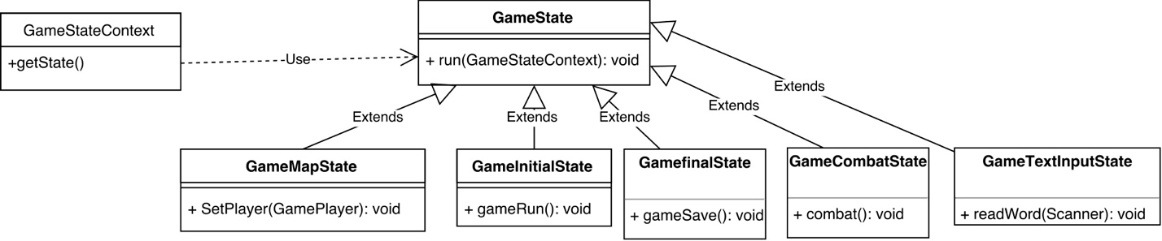

We also used the strategy pattern in our combat state of the game as a way to switch the attacks of out characters. The strategy pattern allowed us to create “behaviors” for each and every attack with each and every weapon. This allowed us to switch weapons, and attacks in the middle of a combat sequence.

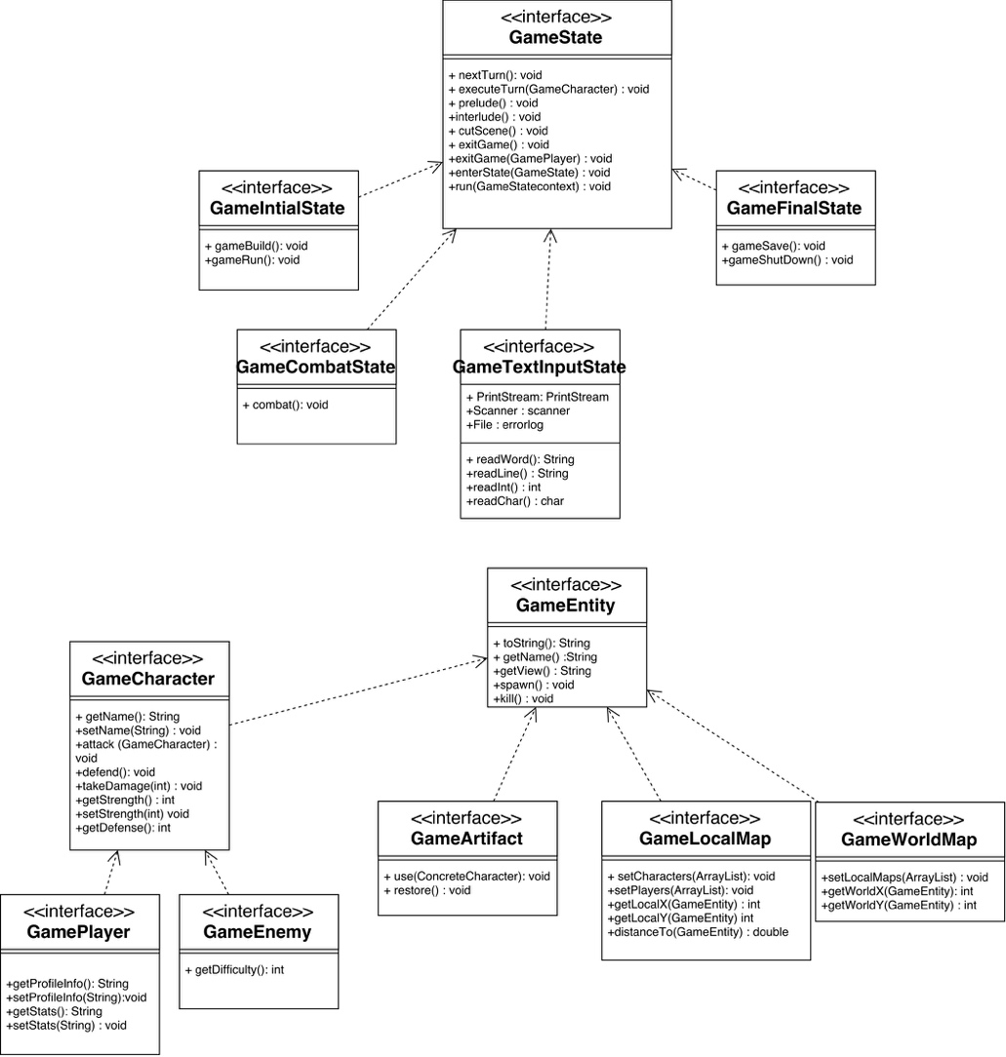

For our GUI we used the singleton pattern to make sure that we could only have one window open at a time. If the program recognizes that there is another window open in the console, the singleton pattern helped us to make sure that second window did now open.